Test Summary Report

TO-DO-MVP

1. *Purpose*

This document explains the various activities performed as part of Testing of ‘TO-DO-MVP’ application.

1. *Application Overview*

This is a native task list application. There are several modules, such as creating a task, viewing the list of tasks, editing tasks, filtering by completed and active tasks, statistics on completed and active tasks.

1. *Testing Scope*
   1. In Scope

* Functional testing
* Interrupt testing
* Usability and User Interface testing
* Functionality: Main screen, Creating a task, Task list, Task Card
  1. Out of Scope

Performance, Stress and localization testing was not done for this application.

* 1. Items not tested

The compliance of the сolor palette, logo, icons, elements, layout with approved layouts and guidelines was not tested. This will be tested in the next steps after mockups are provided.

1. *Metrics*
   1. Number of test cases planned vs executed

| planned | executed |
| --- | --- |
| 91 | 77 |

* 1. Number of test cases passed/failed

| passed | failed |
| --- | --- |
| 59 | 18 |

Test cases passed vs failed

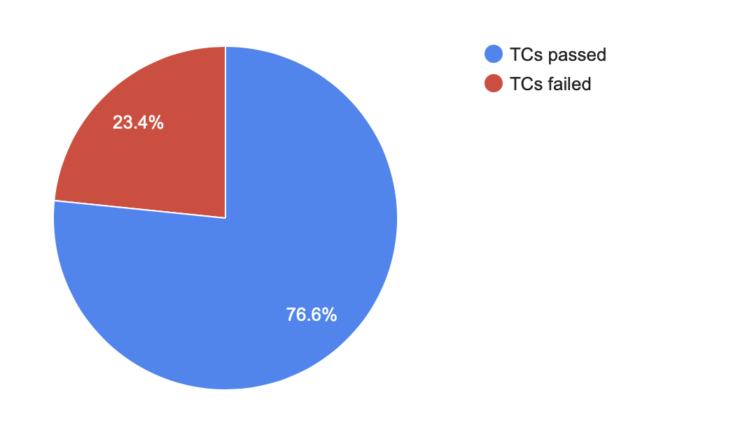

* 1. Number of defects identified and their Status & Priority

|  | Show-stopper | Critical | Major | Normal | Minor | Total |
| --- | --- | --- | --- | --- | --- | --- |
| Open | 1 | 1 | 5 | 6 | 0 | 13 |
| Closed | 0 | 0 | 0 | 0 | 0 | 0 |

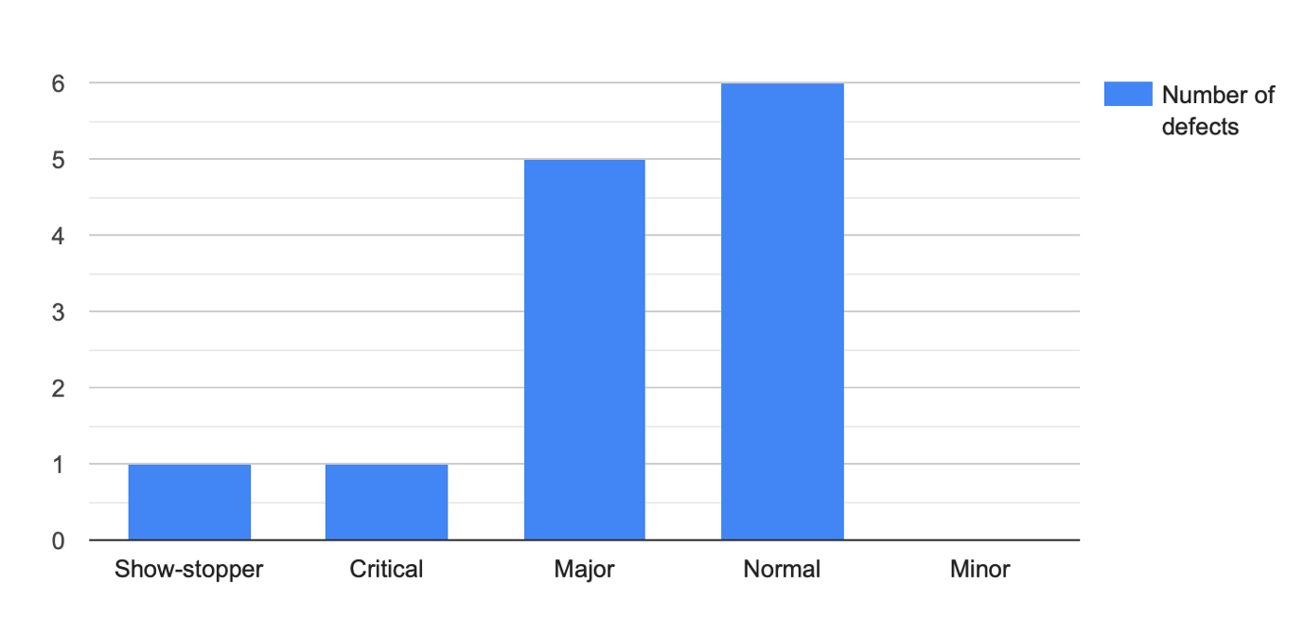

* 1. Defects distribution – module wise

|  | Show-stopper | Critical | Major | Normal | Minor | Total |
| --- | --- | --- | --- | --- | --- | --- |
| Main screen | 1 | 0 | 0 | 0 | 0 | 1 |
| Creating a task | 0 | 1 | 2 | 2 | 0 | 5 |
| Task list | 0 | 0 | 1 | 2 | 0 | 3 |
| Task card | 0 | 0 | 2 | 1 | 0 | 3 |
| Statistics | 0 | 0 | 0 | 1 | 0 | 1 |
|  | | | | | | 13 |

Defects distribution – module wise

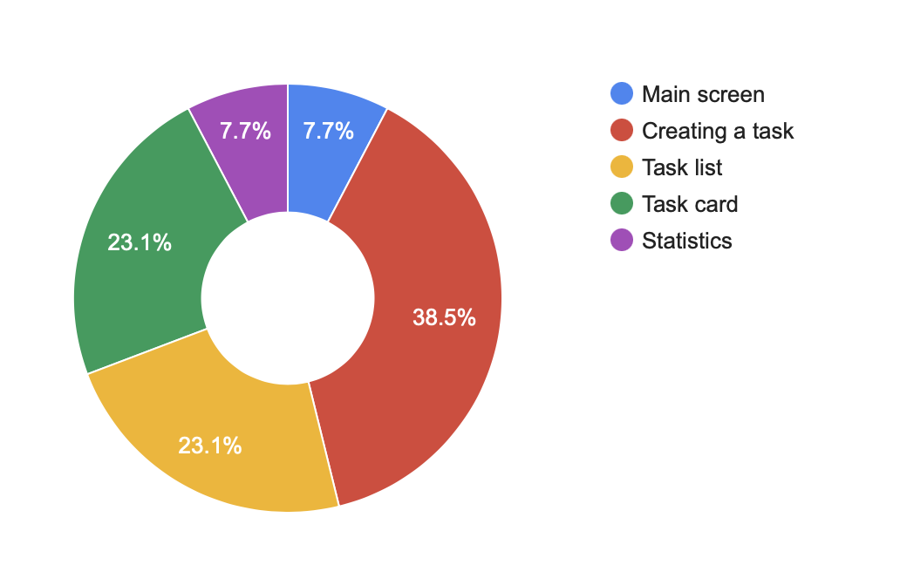

1. *Types of testing performed*
   1. Smoke Testing

This type of testing was the main one at this stage, since the build was received (deployed into test environment) for the first time. Testing has been done to make sure the core functionality works fine, the build can be accepted and further testing can begin.

* 1. Functional testing (device specific checks)

On this build, software and hardware compatibility tests were done - basic tests that relate to the correct installation and operation of the application on the device, interrupt testing, usability and user interface testing.

1. *Test environments and tools*

MacBook Pro MacOS Ventura Version 13.4.1

Android Studio Giraffe | 2022.3.1

Emulator Pixel 3a API 33 Android 13.0 Google Play | x86_64 resolution 1080 x 2220

1. *Exit criteria*
   1. Pass rate metric (the ratio of successfully passed tests to the total number of tests) is more than 85%
   2. All blocking, critical, and high-severity defects have been fixed and retested
   3. Metric Run rate (the ratio of tests passed to the total number of tests) = 100%
   4. Summary test report provided and agreed, conclusion in the report that the platform is ready for release
2. *Conclusion*

As the exit criteria were not met and satisfied as stated in the section 7, the testing team insists that this version of the application not be released.

The development team, based on this report and the bug reports created during the testing process, must fix the defects found so that the build meets the specified exit criteria.